Assignment 2: Analyzing HTTP Headers
Name: BERNALD MURIUKI
Admission: BCSC01/0738/2022

1. Introduction
This report presents the analysis of HTTP headers using a network packet sniffer tool (Wireshark). The goal is to capture and examine HTTP GET and POST requests and identify various elements, such as request and response headers, MIME types, and HTTP status codes.

2. Tools Used
- Network Sniffer: Wireshark
- Operating System: Windows 11

3. HTTP GET Request Analysis
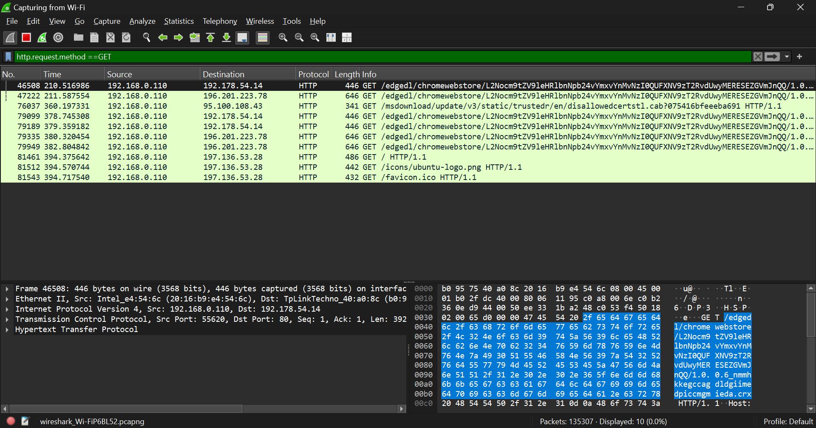

4. Request and Response Headers
Request Headers – Sent by the client to the server when requesting a resource
Response Headers – Sent by the server back to the client in response to a request
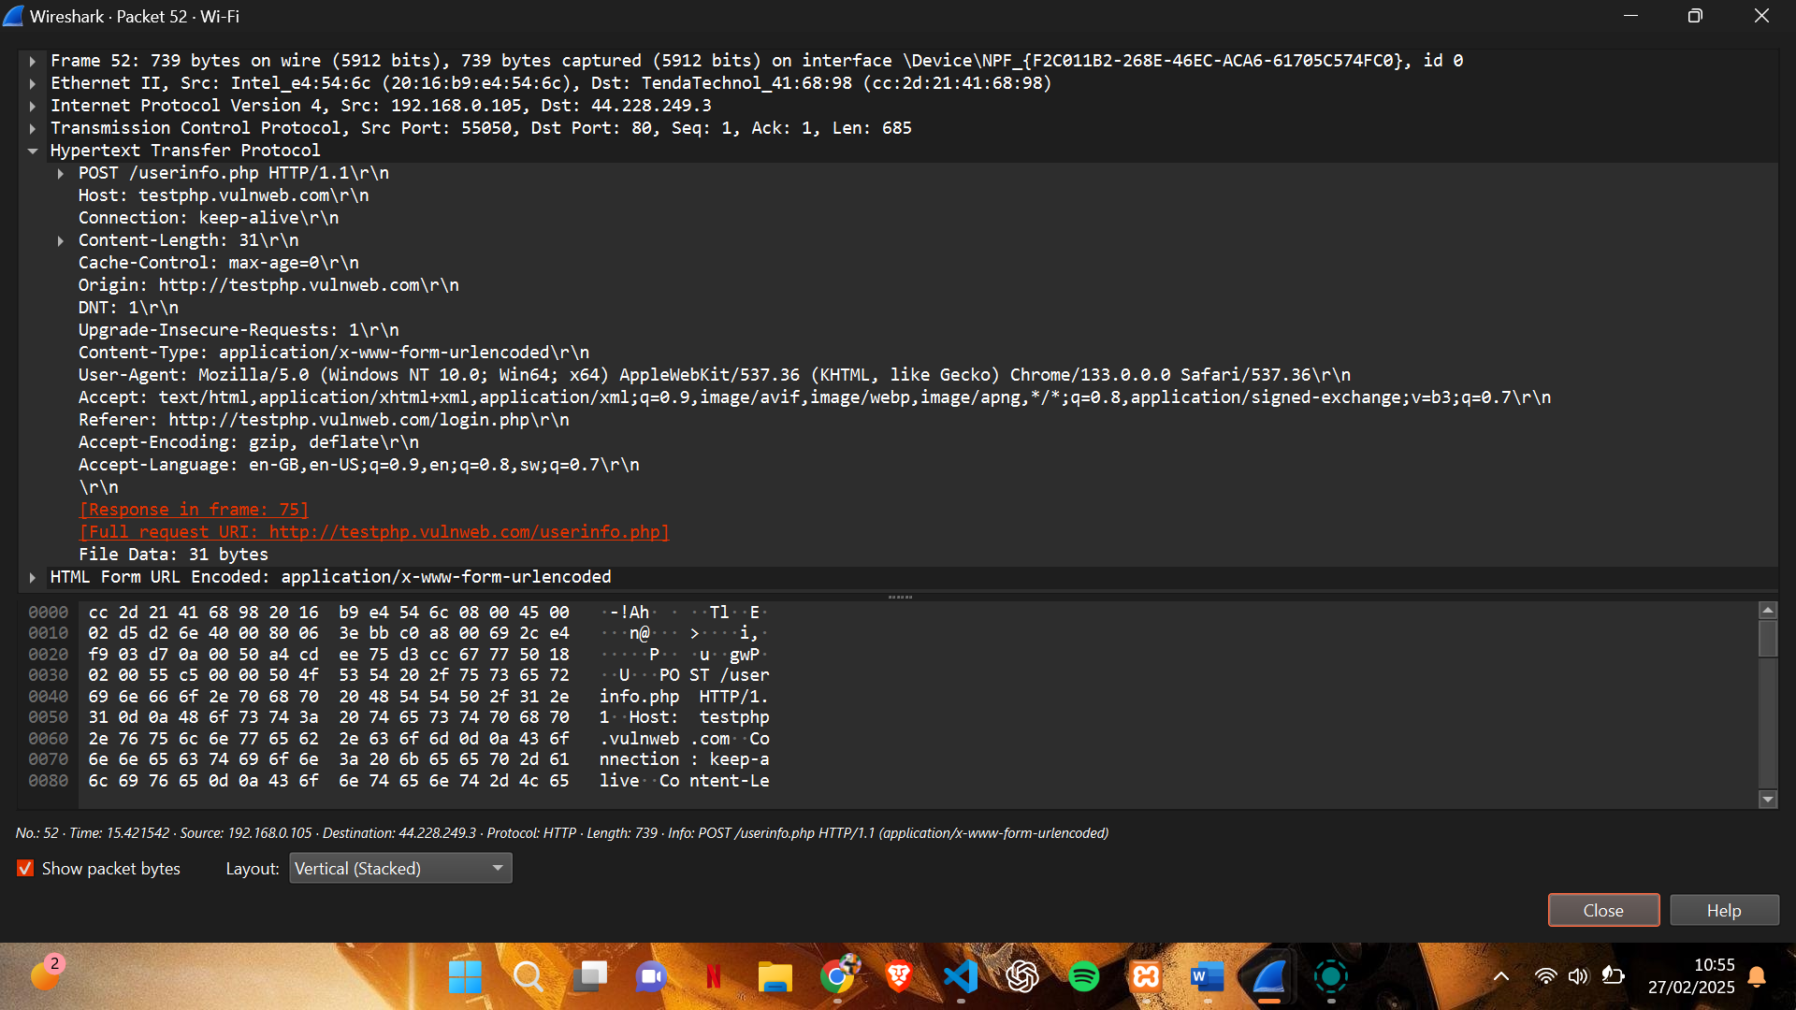

5. MIME Type
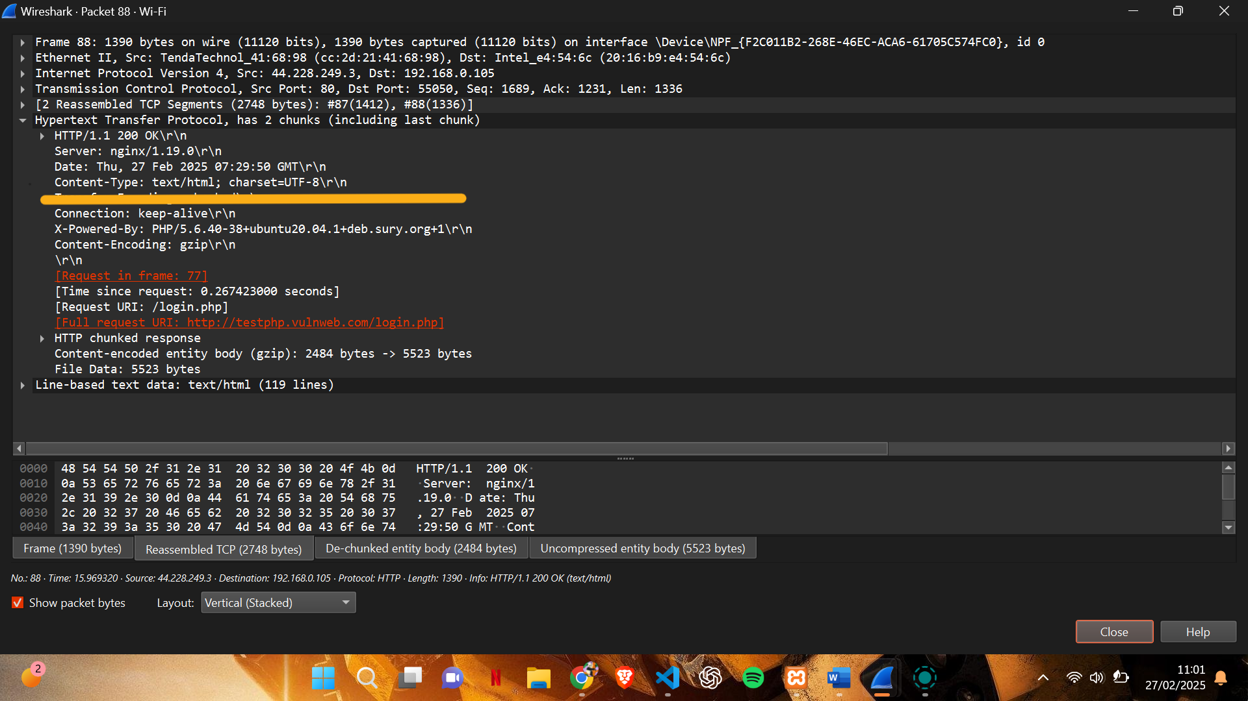
* The underlined line shows the MIME Type

6. HTTP Status Code
It’s a 3-digit number sent by a server in the HTTP response to indicate the result of a client's request.
You’ll find it in the first line of the HTTP response headers.
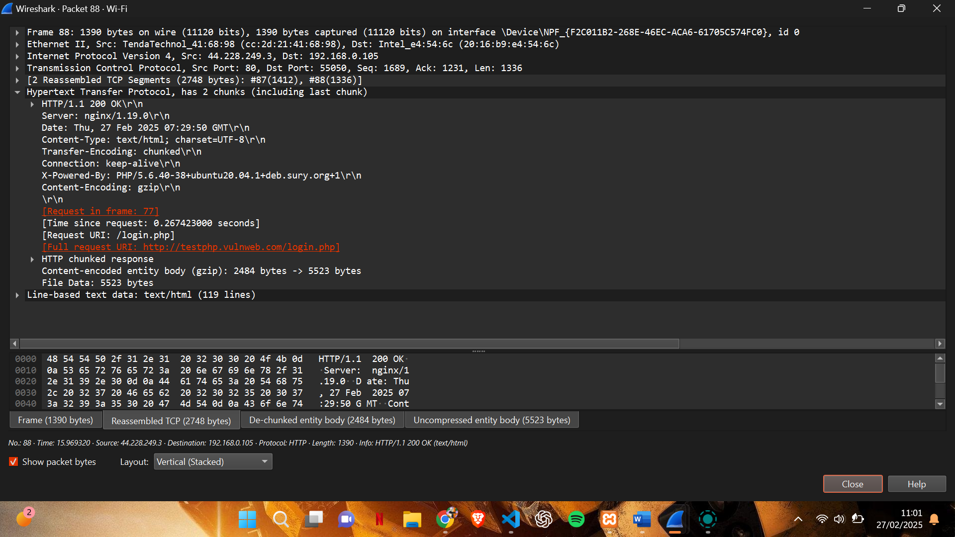
This line tells you:
HTTP/1.1: The HTTP version
200: The status code
OK: The status message

7. Conclusion
This report detailed the analysis of HTTP GET and POST requests using Wireshark. Important components such as headers, MIME types, and status codes were successfully identified and interpreted, showcasing the significance of understanding HTTP communication for web development and security purposes.

